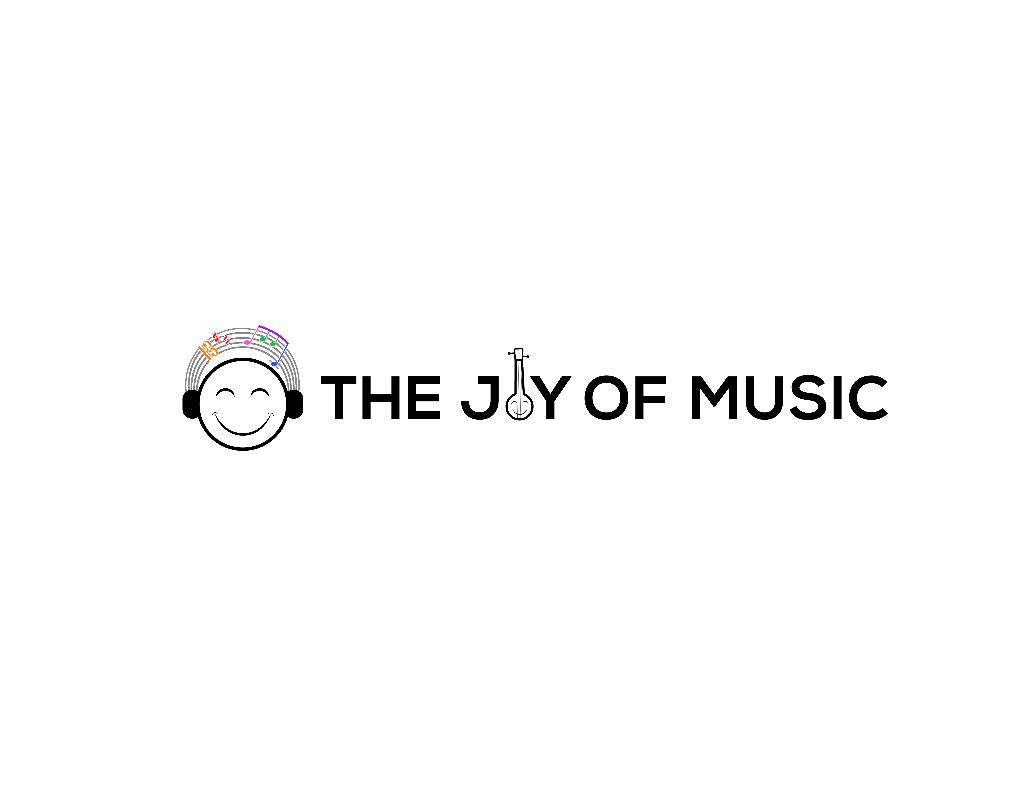
Carnatic Bingo | Bingo Sheet #2

Student Name: ___________________ | Teacher: ___________________ | City, State: ___________________
Parent Name: ____________________ | Parent Email: ___________________ | Parent WhatsApp: ________________

 | 1 | 2 | 3 | 4 | 5
A
B
C |  |  | ★ Answer MCQ ★
D
E
★ The FREE space (C3) may be crossed off by correctly answering the multiple choice question on the back.

I Heard
A1. A Shyama Shastri composition | C4. A Muthuswamy Dikshitar composition
A2. A Thani Avarthanam | C5. Adi thalam
A3. A prati-madhyama ragam | D1. A ragam or composition sung only for mic testing
A4. A Tamil composition | D2. A composition that started before the samam
A5. A composition that started after the samam | D3. A ragam with no madhyamam
B1. A Telugu composition | D4. A Malayalam composition
B2. A composition that was not in Adi, Roopakam, Khanda Chapu, or Misra Chapu | D5. A Papanasam Sivan composition
B3. A composition that started on the samam | E1. A Kannada composition
B4. Misra Chapu | E2. A Thyagaraja composition
B5. A Gopalakrishna Bharati composition | E3. A composition by a non-trinity composer
C1. Khanda Chapu | E4. A ragam with no Pa
C2. A Purandaradasa composition | E5. A Sanskrit composition


Carnatic Bingo | Bingo Sheet #2

Concert Tracking
Cell | Song | Ragam | Thalam | Composer | Improv  (A/T/N/K) | Comp. Type | Concert
Concert Details
Concert # | Date | Artist | Accompanists | Notes | Venue | Location
Multiple Choice Question
In Carnatic music, the raga Todi belongs to which Melakarta?
□ A) Hanumatodi
□ B) Kharaharapriya
□ C) Mayamalavagowla
□ D) Shankarabharanam
How to play: At a concert, when you hear or see something that matches one of the hints on page 1 ("I Heard"), put a check or X in the matching empty square (A1-E5). Get 5 in a row - horizontally, vertically, or diagonally - to complete your Bingo! The FREE space (C3) is unlocked by correctly answering the multiple choice question above.

